# The Essence of Monte Carlo Simulations:

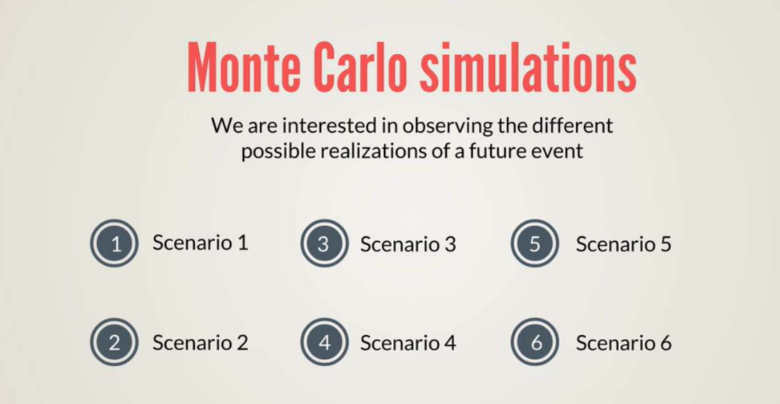



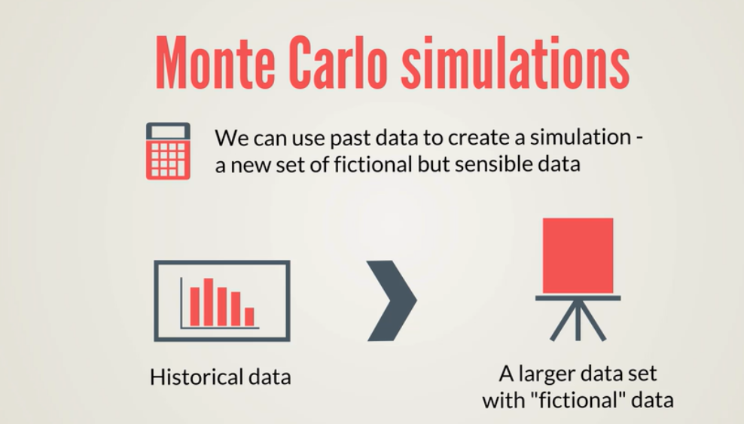

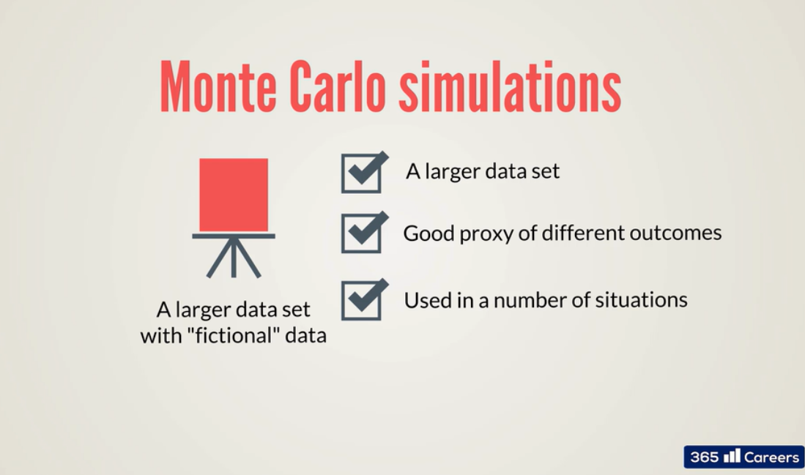

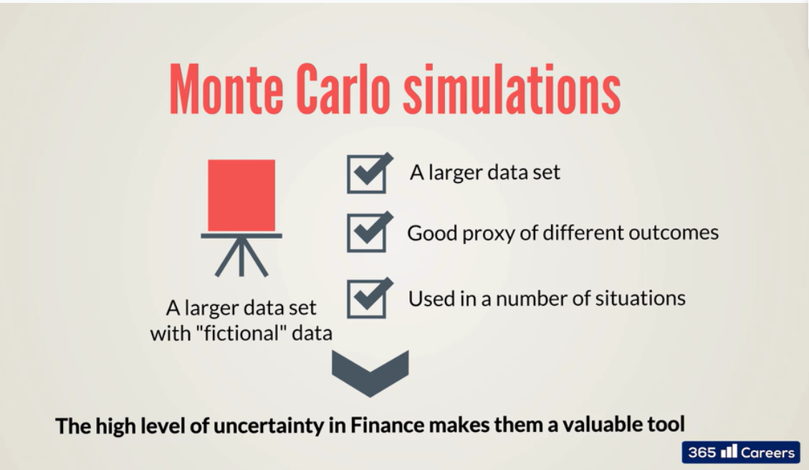

# Check normal distribution notebook before moving ahead!

# Monte Carlo Simulation applied in Corporate Finance Context:



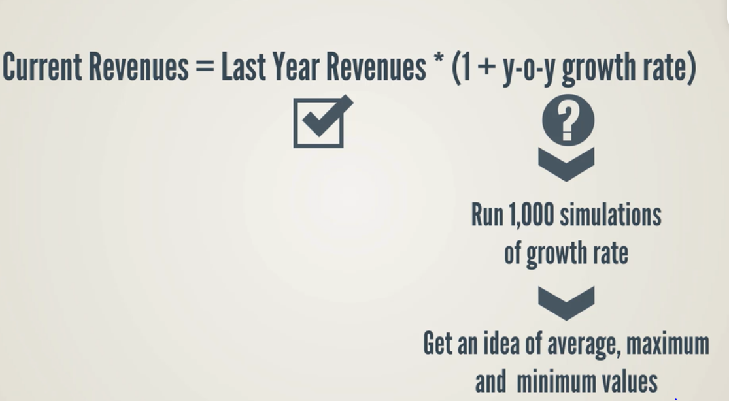



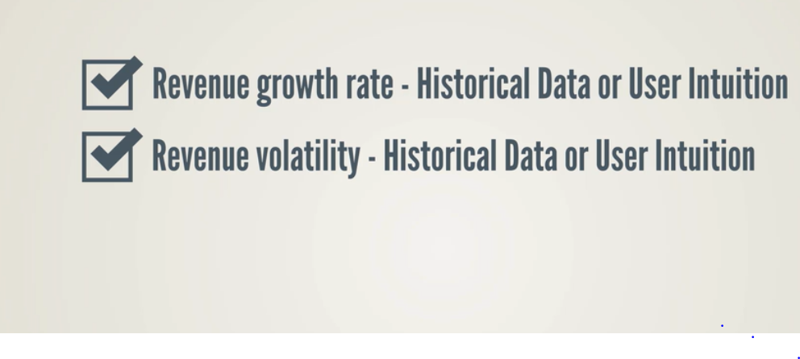

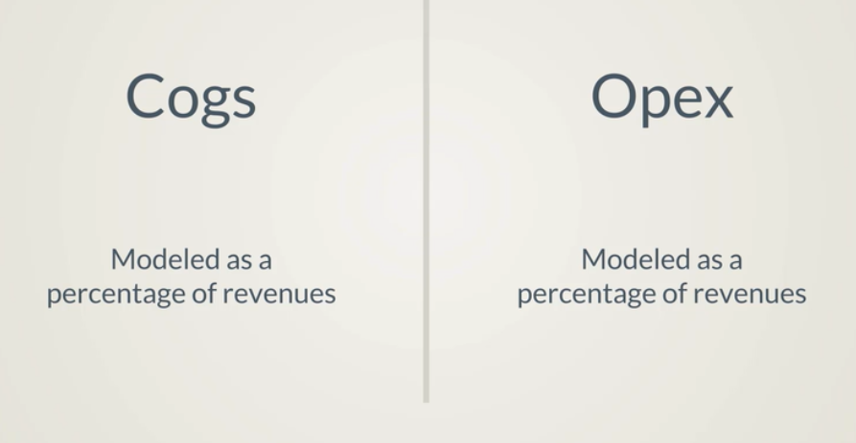

We need to represent cogs and opex figures. The reasoning for cost of goods sold and operating expenses is almost same except one main difference: we need to cogs and opex as percentage of revenues and model the development for % of revenues. Which are inline with firm expected revenue, (cogs and opex depends on the revenue the firm makes). If revenue are low there will be no need to spend a lot in cost of good sold, as less products will be produced.

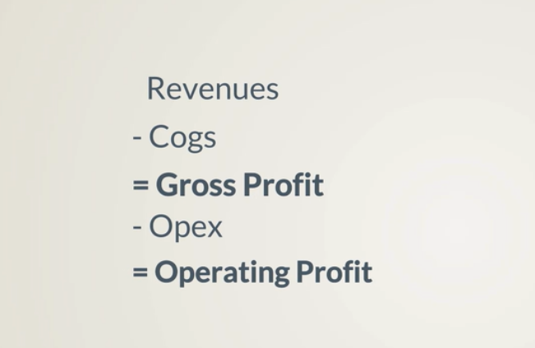

# Notebook2

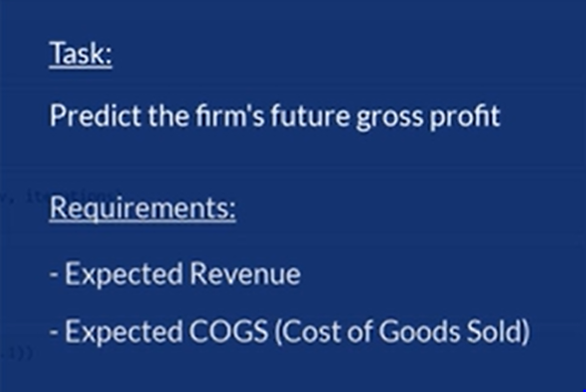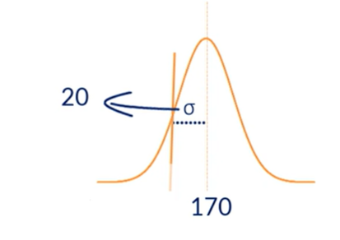

# Assume you are experienced in the company and can tell that COGs amount is almost equal to 40

#(40% of revenue are used in producing goods)

# What it mean by approx ?? -> well if the previous cogs value was before 43, 32, 36, 48, we can simply assume 40%

# we cannot type 6% deviation (it should be 10% or more).

# we already collected 1000 datapoints for simulation

# Forecasting Stock Prices



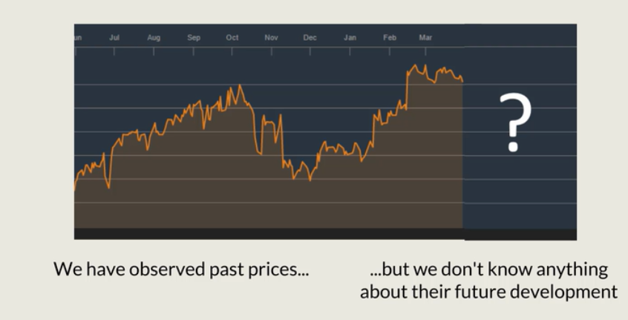

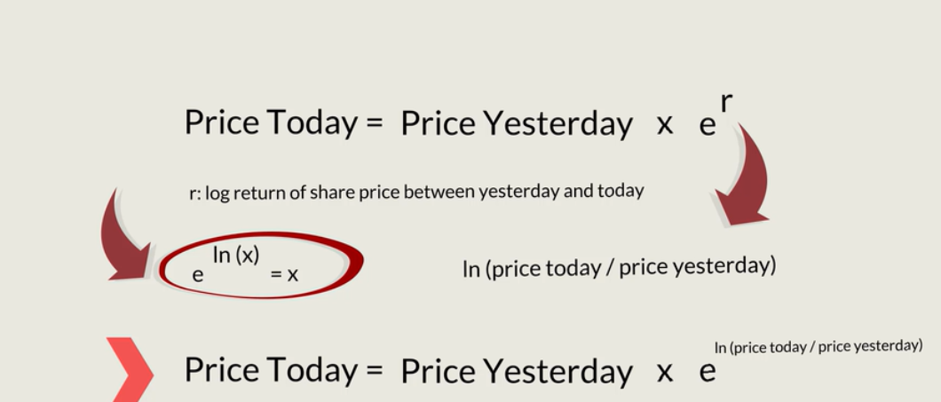

Depict todays stock price as the function of yestarday’s stock price

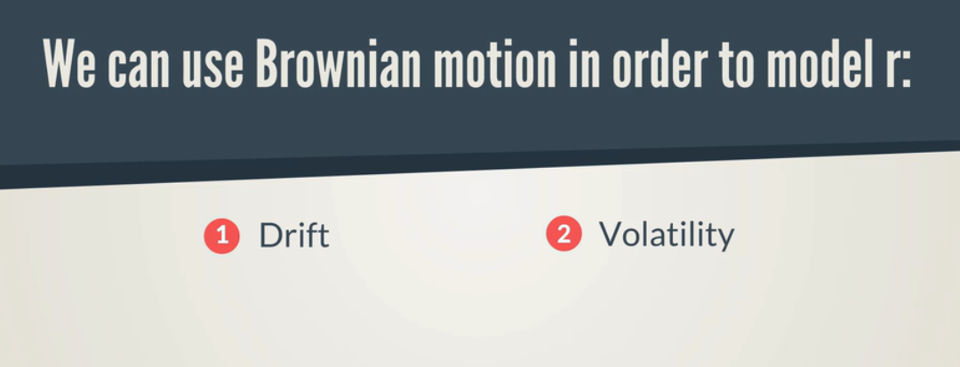

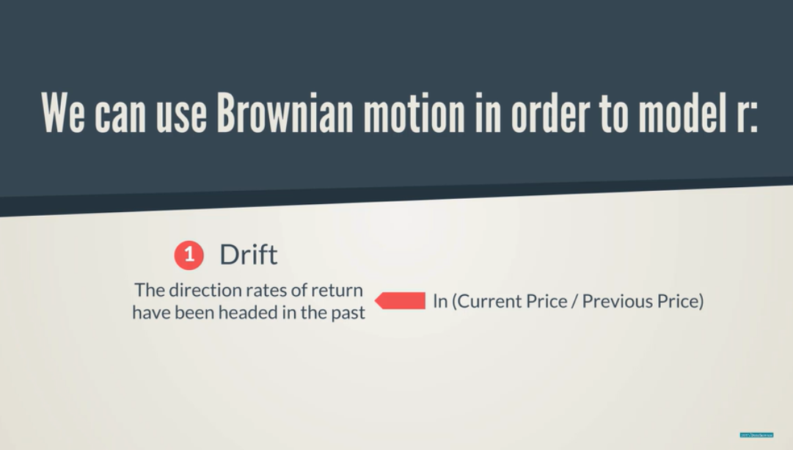

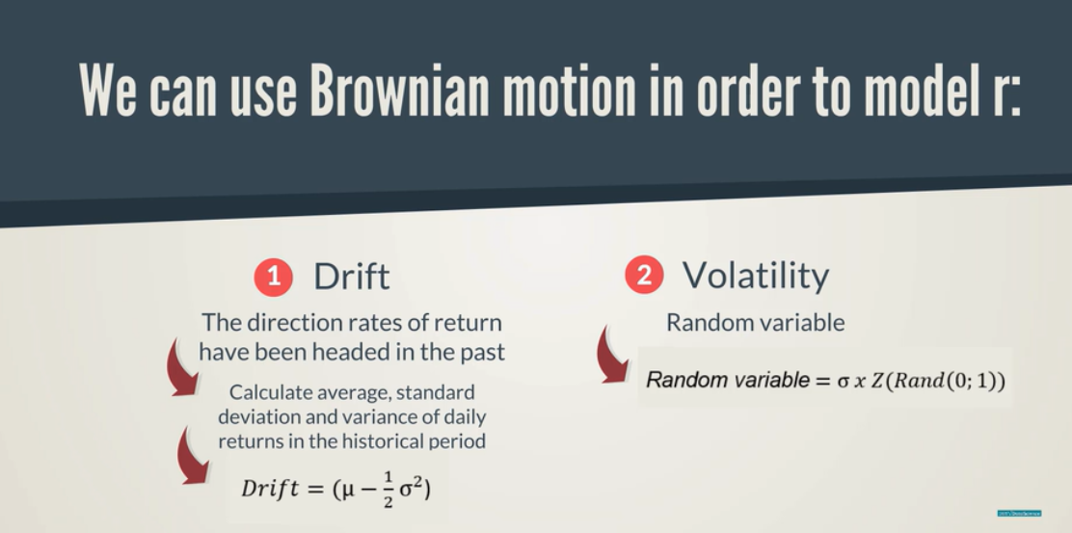

Drift is the daily expected returns of the stock. We recognize that historical values are eroded in future of ½ variance (random component) is included

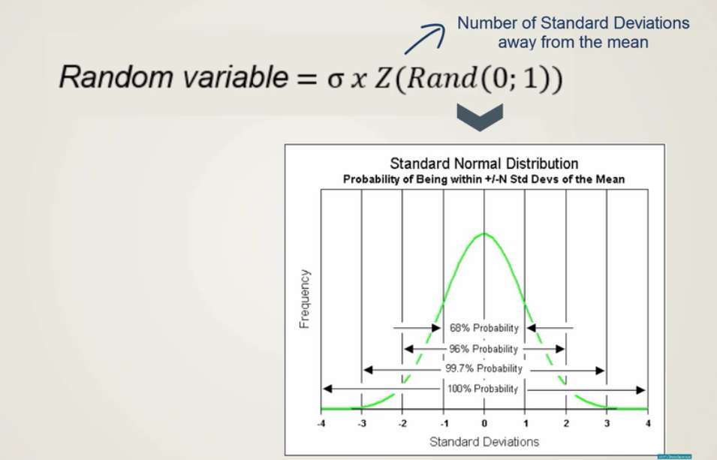

* 1. random number is a percentage (gives number of standard deviation away from the mean)

Eg: 3 times std deviation <99.7

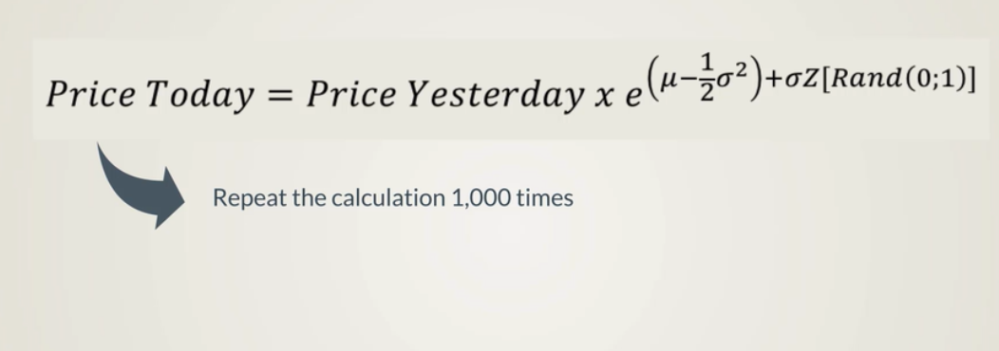

Good way to access pattern as we considered both upside and lower bound during the calculation!

Check notebook 4,5,6!

------------------------------------------------------------------------------------------------------------------------------------------

# An Introduction to Derivative Contracts

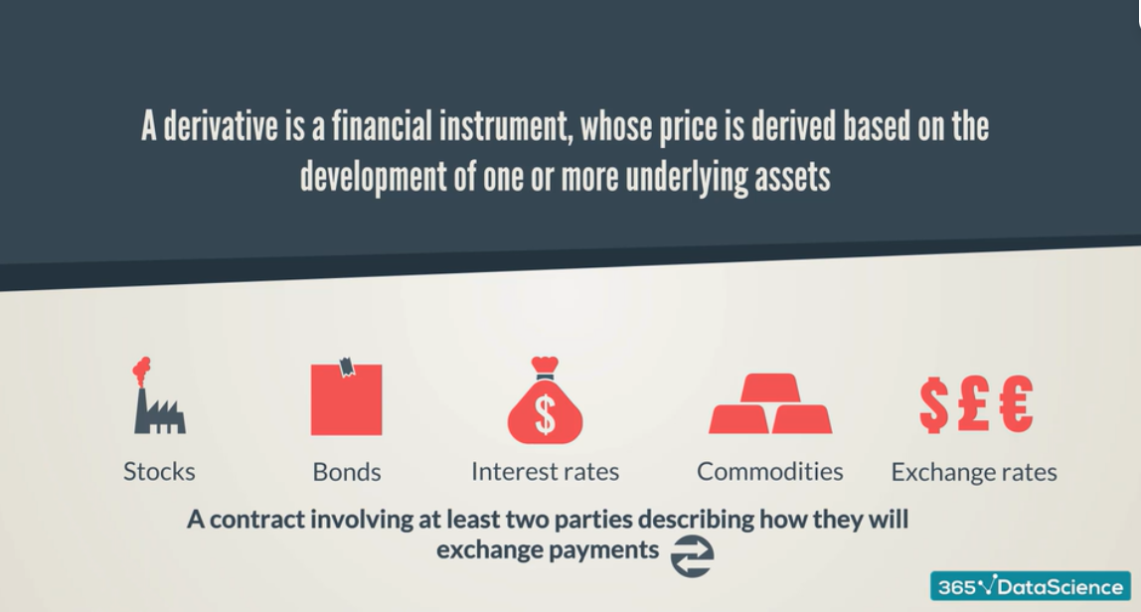3 groups of people interested in derivative contracts we will focus on :



4 main types of financial derivatives

## 

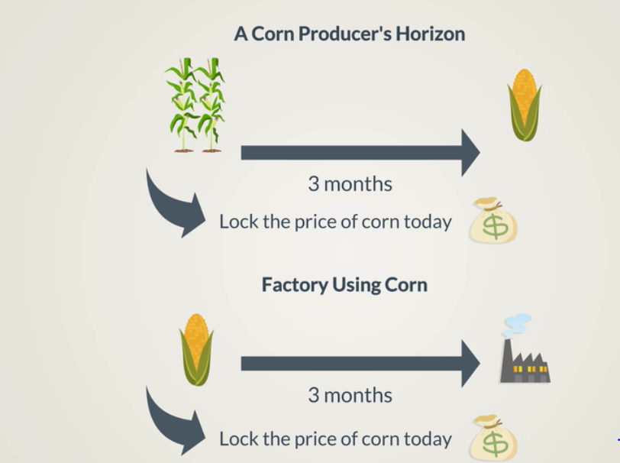

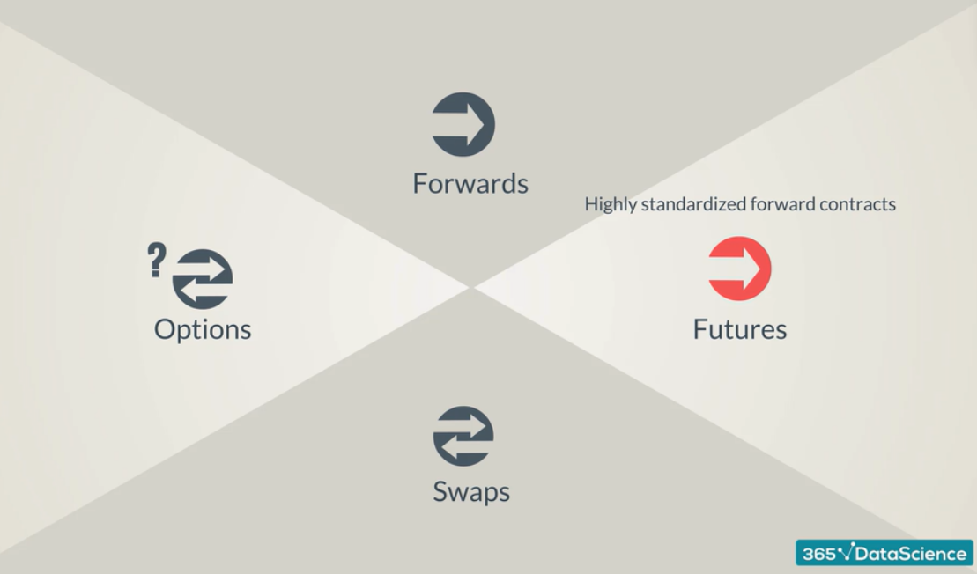

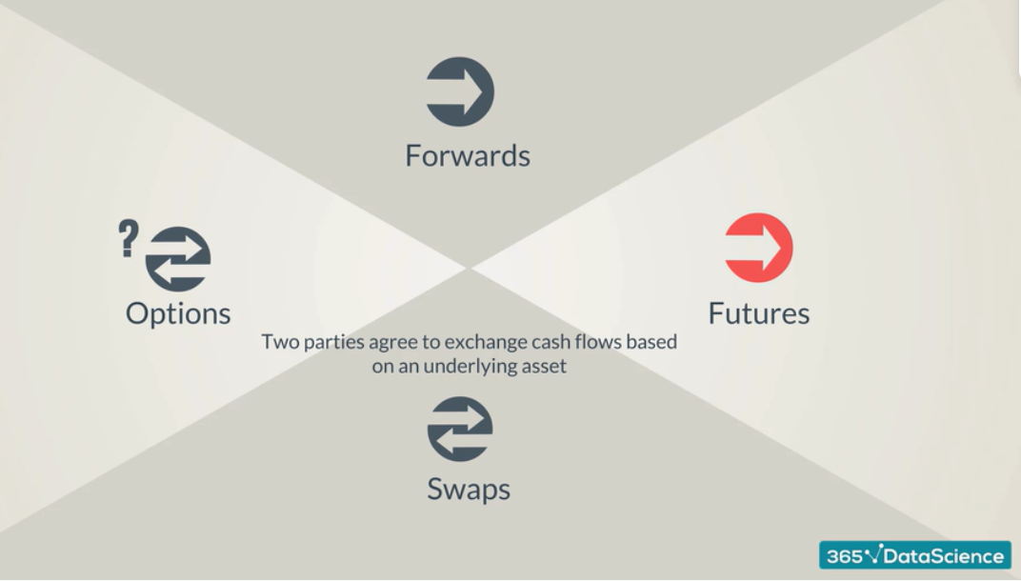

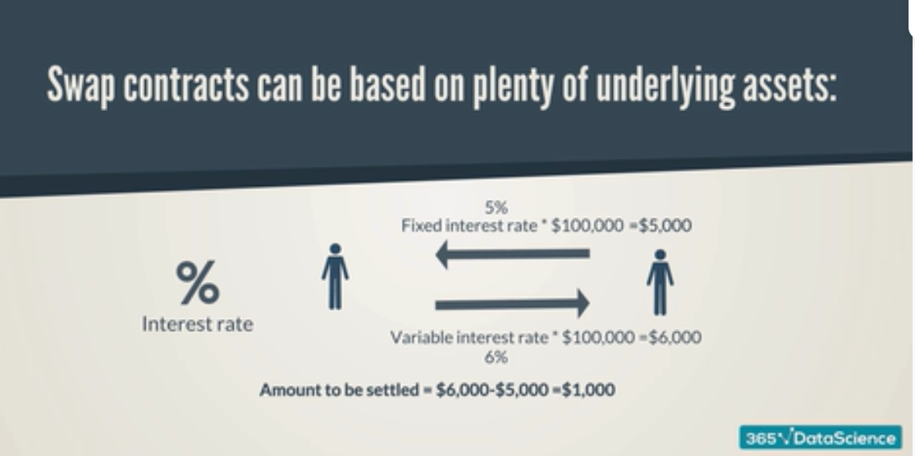







# Monte-Carlo Introduction to Black Scholes Formula



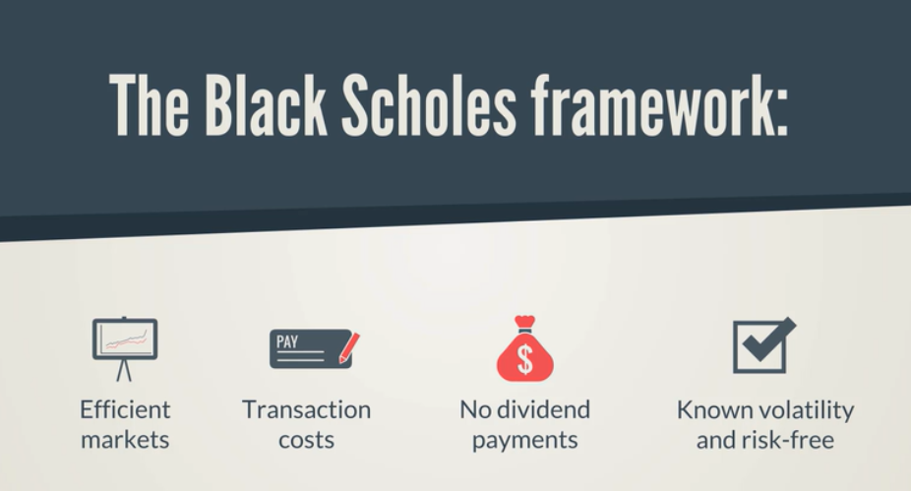



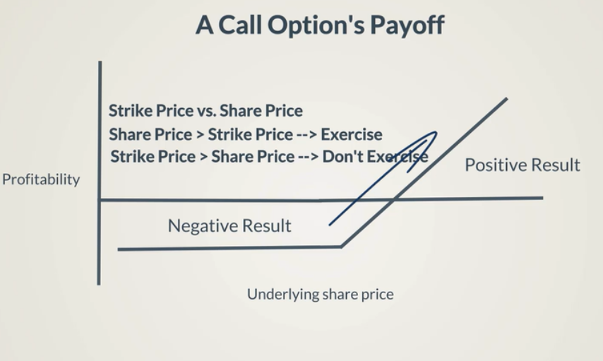

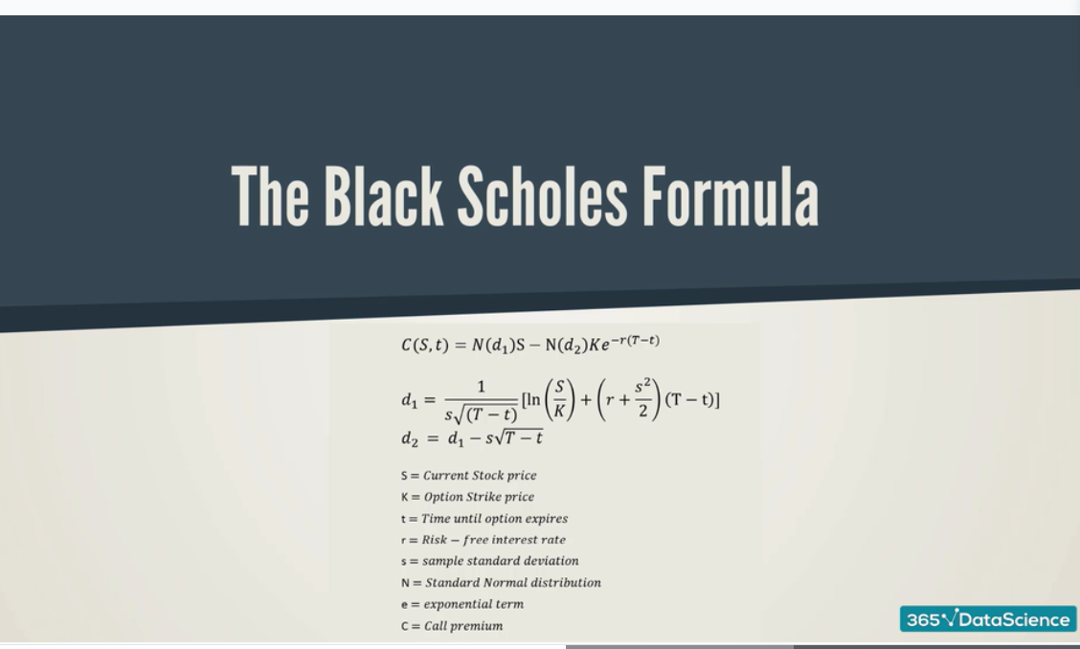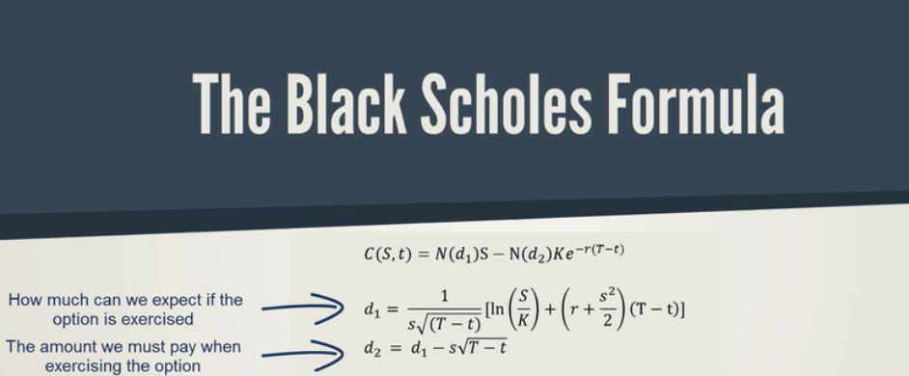

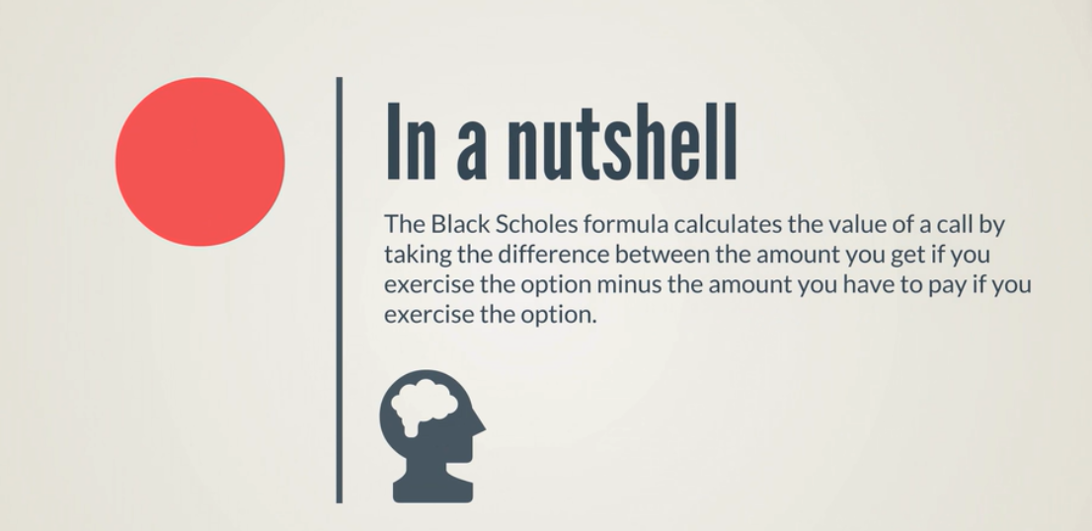

# Monte-Carlo Euler Discretization

